Lesson 4 Demo 5: Rollbacks with Command and Deployment File

This section will guide you to:

* Rollbacks with command and deployment file

This lab has one sub-section, namely:

1. Rollbacks with command and deployment file

**Note:** If you don’t have an existing Kubernetes cluster, refer to the Demo 1.1 of Lesson 1.

**Step 1:** Rollbacks with command and deployment file

* Start the kubernetes cluster in the lab
* As the first step, let’s create a deployment named nginx-deployment, indicated by metadata.namefield. If you’ve an existing nginx-deployment delete it with the command **kubectl delete deployment nginx-deployment**. The yaml file will look like the one shown below:

*cat > nginx-deployment.yaml*

apiVersion: apps/v1 # for versions before 1.9.0 use apps/v1beta2

kind: Deployment

metadata:

name: nginx-deployment

spec:

selector:

matchLabels:

app: nginx

replicas: 2 # tells deployment to run 2 pods matching the template

template:

metadata:

labels:

app: nginx

spec:

containers:

- name: nginx

image: nginx:1.7.9

ports:

- containerPort: 80  
  
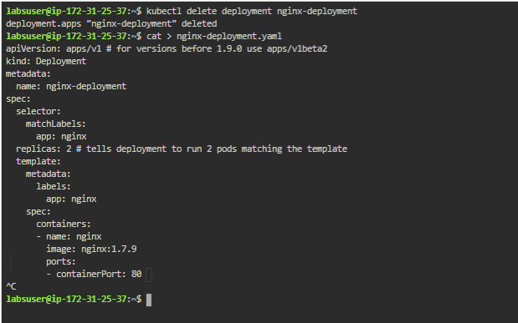

* Next, create the deployment by running the following Kubectl command:  
    
  *kubectl apply -f nginx-deployment.yaml*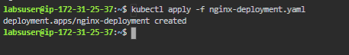
* Run, **kubectl get deployments** to check if the deployment was created. If the deployment is still being created, the output will be like the one shown below:  
    
  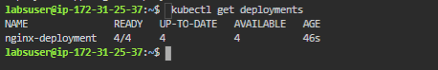
* To see the deployment rollout status, run **kubectl rollout status deployment.v1.apps/nginx-deployment**. The output will be like the one shown below:  
    
  
* Sometimes, you may want to rollback a deployment  
  **For example**: A case of crash looping when the deployment is not stable
* Suppose that you made a typo while updating the deployment by putting the image name as nginx:1.91 instead of nginx:1.9.1.   
    
  *kubectl set image deployment.v1.apps/nginx-deployment nginx=nginx.191 --record=true*



* You can now check the rollout history as shown below:

*kubectl rollout history deployment.v1.apps/nginx-deployment*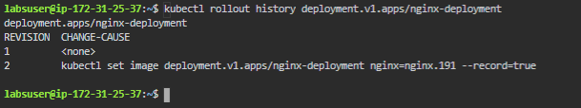

* This is how we can update the deployment rollout using kubectl commands and yaml file.